USING THE CONCEPT5 BUFFERED LEAST COST FORMULATION SCREEN

The Buffered Least Cost Formulation screen is the heart of all the formulation efforts within the Concept5 system. From here, formulas are built, edited, and solved. Entries to the screen are temporary until saved – thus, the term, buffered. The system allows several ways of setting and maintaining the ingredient and nutrient restrictions of the formulas to provide the needed versatility to meet all demands.

This guide will attempt to describe the many features of the screen.

From the main menu, click the Change Plant button and select the desired plant. Then click the Product Maintenance button to open the Product Maintenance screen.

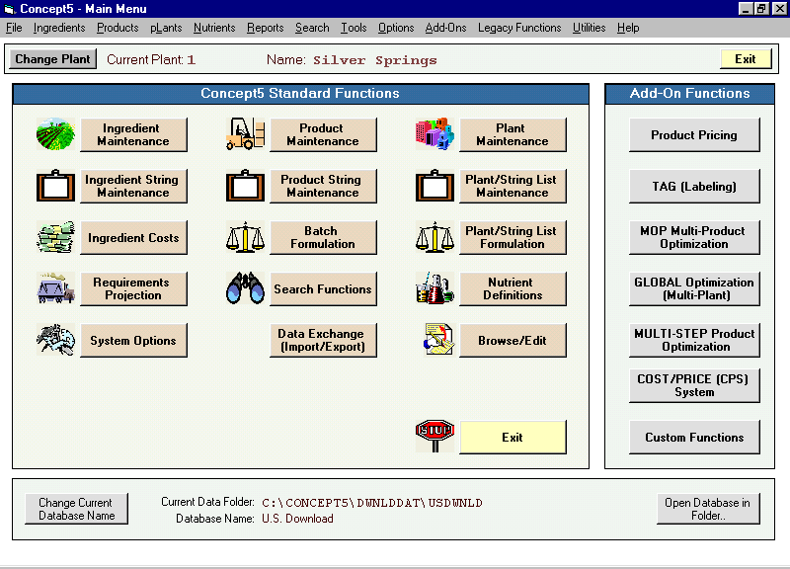

For more information on the Buffered screen, see the Help file: Contents tab>Products>Buffered Least Cost Formulation.
Select the desired product by entering the product code in the Get Code box, or click the Get Prod button to open the product index.

In this example, we will be using Product 06-0102, Swine Grower as our model.

Click the Full Screen Formulation button to open the Buffered Least Cost Formulation screen.

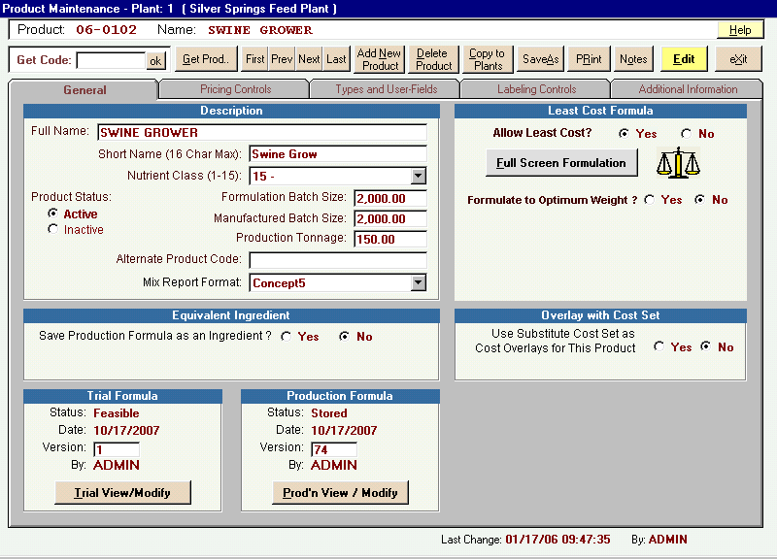

The Product Maintenance screen also allows you to view/edit the Nutrient Class, the Formulation Batch Size, and the Manufactured Batch size, all of which will be mentioned in this guide.

Ingredient tab

We will begin our discussion of the Buffered Least Cost Formulation screen by selecting the Ingredients tab.

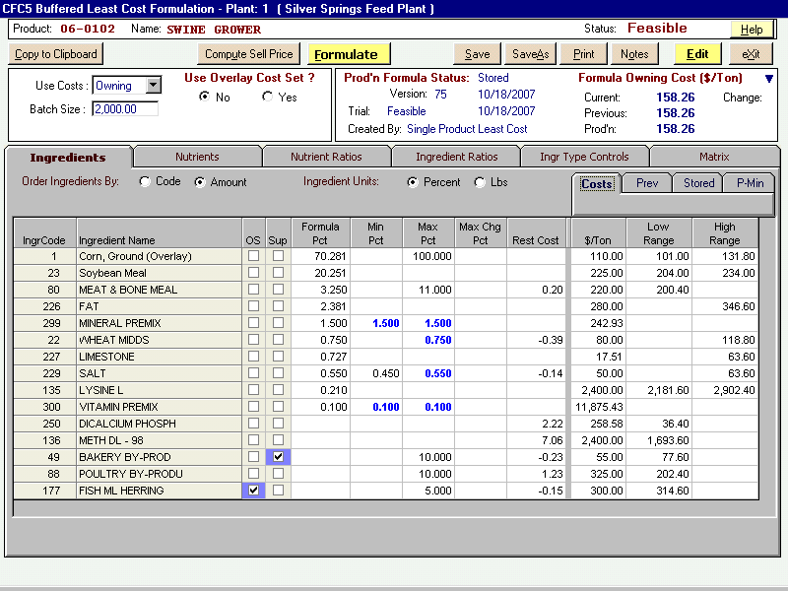

The Ingredient tab of the Buffered Least Cost Formulation screen displays (going from left to right):
- The code number and name of the ingredients offered to the formula.
- The OS column. A check in this column signifies an out of stock designation for an ingredient (see ingredient 177, Fish Ml Herring, in the screen shot above). The OS designation is set in either the Ingredient Maintenance screen or the Ingredient Cost Maintenance screen. A checkmark with a blue background indicates that the ingredient has a value at the current price and would be used in the solution. A checkmark with a red background indicates that an out of stock ingredient is currently in the formula and that a formula re-run is necessary. Out of stock ingredients may be evaluated in a formula by clicking in the checkbox in the OS column to remove the check, then reformulating the product. This is a temporary change that will be reversed when the screen is exited.
- The Sup column. An ingredient can be suppressed from a formula by clicking a check in the box in this column (see ingredient 49, Bakery By-Prod, in the screen shot above). A suppressed ingredient will not be allowed to be part of a least-cost solution but will remain in the formula as an unused ingredient. A checkmark with a blue background indicates that the ingredient has a value at the current price and would be used in the solution.
- The Formula Pct (or Lbs) column. This column shows the amounts of the ingredients in the formula solution in pounds or percent as specified by the Default Units setting or the option buttons next to Ingredient Units (on the Ingredient tab just above the Formula Pct column). Ingredients can be ordered by either code or amount by choosing the desired option next to Order Ingredients By shown on the Ingredient tab directly above the ingredient listing.
Ingredient tab (cont.)

- The Min Pct and Max Pct columns. The ingredient restrictions in the formula are set using these two columns. Click in a cell and type in the desired restriction. No entries mean no restriction for the ingredient. In a formula solution, blue numbers in either column indicate that the ingredient amount is hitting that restriction, while red numbers mean that the ingredient amount cannot meet the restriction (thus, an infeasible formula result). Add ingredients by clicking the Add Ingredient button and entering the desired ingredient code in the popup. Clicking the Index button on the popup will open the ingredient index. Ingredients can also be added by string by clicking the Add String of Ingredient button and choosing the desired string from the popup menu. Remove ingredients by selecting the ingredient and clicking the Remove button.
- The Max Chg Pct column. In this column, specify the maximum increment (percent or pounds) that any ingredient may change when the formula is run. This increment will be obeyed for each formula run until the formula is stored to production. This is an optional feature.
- The Rest Cost column shows the restriction cost of each limiting ingredient. If an ingredient is meeting its minimum and/or maximum restriction, the Rest Cost column will show a number that is 1% of the difference between the ingredient cost and the cost shown in either the High Range column (when meeting the maximum restriction) or Low Range column (when meeting the minimum restriction).

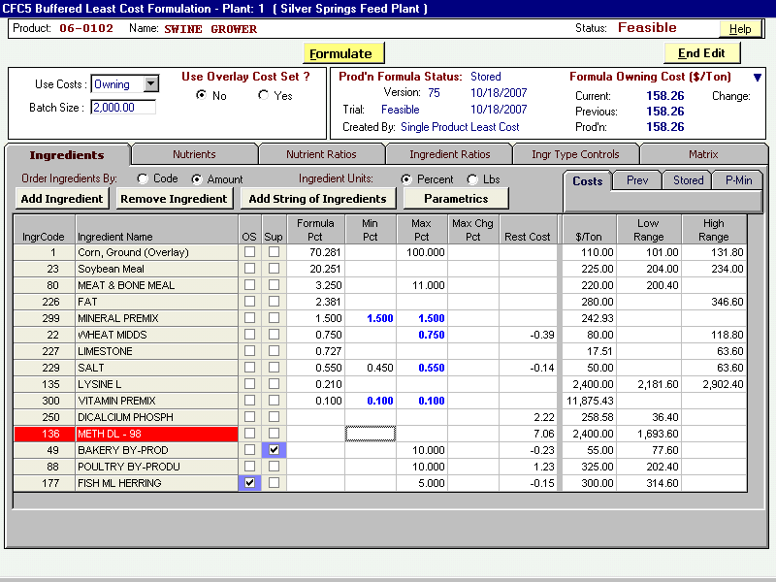
Ingredient tab (cont.)

- The Cost tab shows:
  - Ingredient costs. In this example the costs are in $/Ton. This cost unit can be changed to $/lb or $/100 lb, or the metric equivalents (see the Help file: Contents tab>System Options>General/Default Units). You can temporarily change any existing ingredient cost (price) by selecting the Cost tab, clicking on the cost and typing new numbers. The formula can then be re-solved with the new cost. This is a temporary change to this formula only. All changes will revert back to the original numbers upon exiting the screen. Caution is advised because formulas solved with the altered price can be stored to production.
  - Low Range and High Range columns. Ingredient cost ranges show the prices at which the ingredient will be used less in the formula (High Range) or more (Low Range).
- The Prev tab (Previous) shows the ingredient profile of the solution immediately preceding the one on screen, and the difference between the two formulas. To access, the screen must not be in the edit mode.
- The Stored tab shows the ingredient profile of the stored production formula, and the difference between it and the formula on screen. To access, the screen must not be in the edit mode.

Ingredient tab (cont.)

- The P-Min tab lists any ingredients that have a Production Minimum. Ingredient Production Minimums are set in the Ingredient Maintenance screen for the individual ingredients. The Manufactured Batch Size specified in the Product Maintenance screen (and which applies to the production minimums) is shown above the columns. The Prod'n Min column shows, in pounds, the production minimums for the ingredients in the formula. The Manuf Lbs column shows the amount, in pounds per the Manufactured Batch Size shown, of any ingredients with a production minimum. The Violation column shows the amount, in pounds, of any violation of the production minimums. Production minimums can be resolved automatically or following a prompt (see the Help file: Contents tab>Products>Resolving Ingredient Production Minimums). To access, the screen must not be in the edit mode

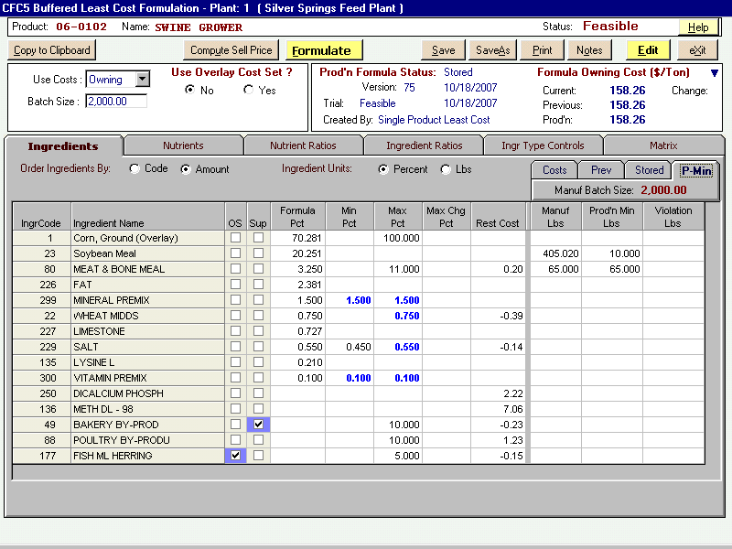

In the above example, ingredient code 80, Meat & Bone Meal, has a production minimum of 65 pounds per the Manuf Batch Size of 2000 pounds.

Again, the ingredient production minimums are set in the Description frame of the Base Ingredient Maintenance screen (accessed by clicking the Ingredient Maintenance button on the main menu). The Manufactured Batch Size is set in the Description frame of the Product Maintenance screen (accessed by clicking the Product Maintenance button on the main menu, or by clicking the Exit button on the Buffered Least Cost Formulation screen).
Ingredient tab (cont.)

The header portion of the ingredient tab shows several buttons and frames.

The product code and name, and the status of the formula

The Copy To Clipboard button will copy the ingredient and nutrient solution and restrictions to the clipboard (for easy pasting into Excel).

The Compute Sell Price button opens the pricing data for the product (see the Help file: Contents tab>Pricing).

The Formulate button optimizes the formula.

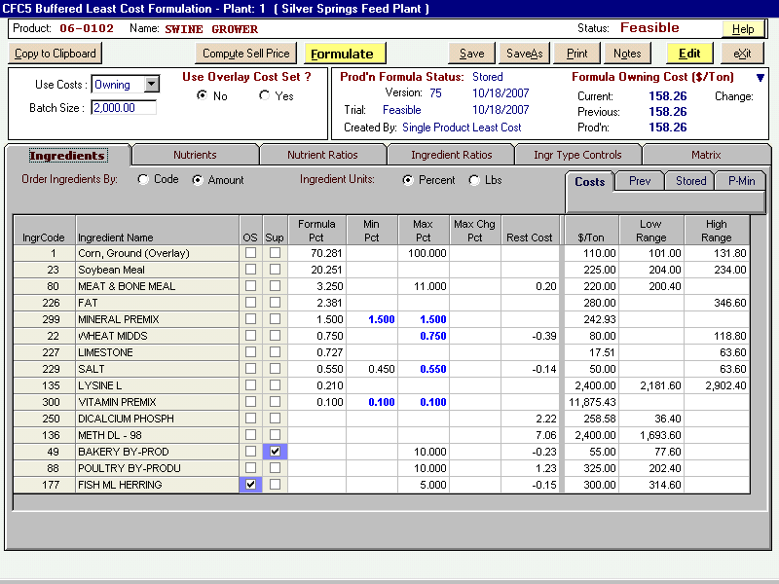

The Save button opens the Save Product popup to save the ingredient/nutrient restrictions shown, to store the formula shown to Trial status, and/or store the formula shown to Production.

The Save As button will copy the formula on screen. This feature is especially helpful if, after making some changes to a product, you decide to keep the new product but want to retain the original. The Save Product As New Product window will open. Type the new product code in the Save As Product Code textbox. The Save Options shown on the popup apply to the new product being copied. Make the desired selections and click Save. The product copied from will remain on screen. To access the new product, click Exit to return to the Product Maintenance screen, type the new code in the Get Code textbox, and press the Enter key (or click the Get Prod button and choose from the Select Product window that opens).

Ingredient tab (cont.)

The Print button will open the Select Report Format popup. Several print options are shown. You may wish to try all options to decide which is best for you. The Tailored option allows you to select what is to be included on the print. Reports are printed by clicking the printer icon at the left-center above the report, or use Copy to Clipboard or Print to File.

The Notes button allows text to be attached to a product. The Notes button appears
on the Product Maintenance screen, the Trial Formula, Production Formula screens,
and the Buffered Least Cost Formulation screen. For each individual plant/product
combination, notes accessed from any of these screens will reference the same log.
Notes can also be automatically generated when specific product maintenance functions
are performed, see the Help file: Contents tab>System Options>Product Notes Options.

The Use Costs scrollbox shows the cost set (Owning or Market) of the ingredient prices shown. Click the arrow button to switch between cost sets. The default cost set is specified on the Formulation Controls tab of the System Options screen. This default can be overridden by plant, see the Help file: Contents tab>Multi-Plant System>Plant Maintenance.

The Batch Size textbox shows the default formulation batch size specified in the Product Maintenance screen. Change the batch size by typing a number in the box.

Ingredient tab (cont.)

The Use Overlay Cost Set? frame allows you to overlay the current ingredient costs on an individual plant formula with any previously defined Substitute Cost Set. (For more information on Substitute Cost Sets, see the Help file: Contents tab>Ingredients>Substitute Cost Sets.) The overlay cost set frame can be accessed from either the Product Maintenance screen or the Buffered Least Cost Formulation screen. The applications are linked so that a change made in either screen will affect the other. (A cost set specified in the Buffered Least Cost Formulation screen must be saved for it to show on the Product Maintenance screen.) Click on the arrow next to the box to open the Cost Set index. In the example below, Cost Set 1 has been chosen. The $/Ton column will show all prices in the cost set in blue.

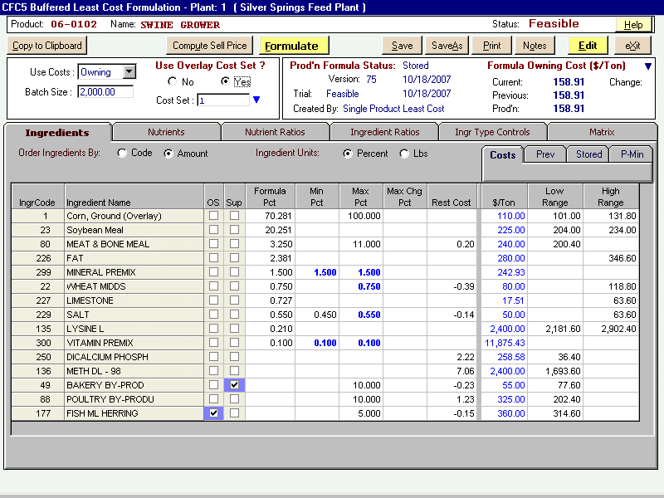

The Formula Status frame shows whether the current stored Trial formula is feasible and the date it was stored, and the version number, date, and status of the current Production formula. Created By will show whether the stored formula is a result of Single Product Least Cost (normal least-cost formulation), User Modified, or the Multi-Product Optimization process. User Modified means that the stored formula solution was achieved by altering ingredient levels using the procedure accessed by the View/Modify button in the Trial Formula or Production Formula frames, or that it contained an ingredient that was deleted and the product has not yet been reformulated.

The Formula Owning (or Market) Cost frame shows:
- the ingredient cost of the current formula (the formula on screen).
- the ingredient cost of the previous formula (the formula that was solved immediately preceding the formula on screen).
- the ingredient cost of the current production formula.
- the cost changes of the latter two compared to the current formula. A blue number indicates a cost decrease; a red number indicates a cost increase.
Nutrient tab

Select the Nutrients tab. This tab shows (from left to right):
- The code number and name of the nutrients in the formula.
- The Amount column shows the amounts of the nutrients in the solution.
- The Minimum and Maximum columns. The nutrient restrictions in the formula are entered in these columns. A formula solution showing blue numbers in either column indicates that the nutrient amount is hitting that restriction. Red numbers mean that the formula solution cannot meet the restriction and the result is infeasible.
- The Rest Cost and Rest Incr columns. If a nutrient amount is hitting a minimum or maximum restriction, the Rest Cost column will show the restriction cost of the nutrient. The restriction cost is based on the unit increment shown in the Restriction Increment (Rest Incr) column. This increment is defined in the Nutrient Definitions screen (see the Help file: Contents tab>Nutrients (Ingredients)>Adding/Editing Nutrient Rows).

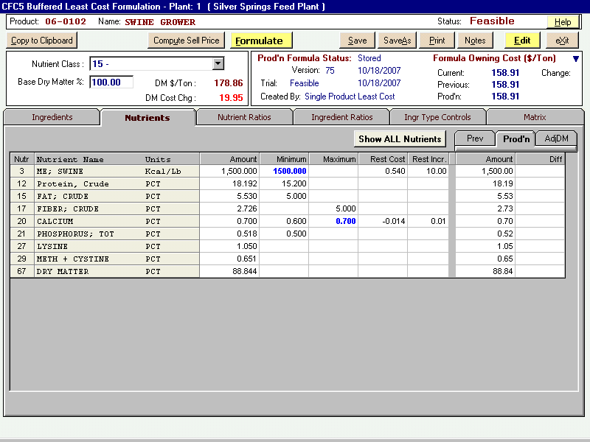

- The Prev tab shows the nutrient profile of the previous solution to the one on screen, and the difference between the two formulas.
- The Prod’n tab shows the nutrient profile of the stored production formula, and the difference between it and the formula on screen.
- The AdjDM tab shows the computed values adjusted to the dry matter specified in the Dry Matter Base frame (see p.12).
Nutrient tab (cont.)

- The Show All Nutrients button (located above the Rest Cost column) opens a listing (as shown below), for the chosen product. For all the nutrients established within the system: the values for the Current Formula Amount, the Previous Formula Amount, the Change From Previous, the Production Formula Amount, and the current formula Change From Production are listed.

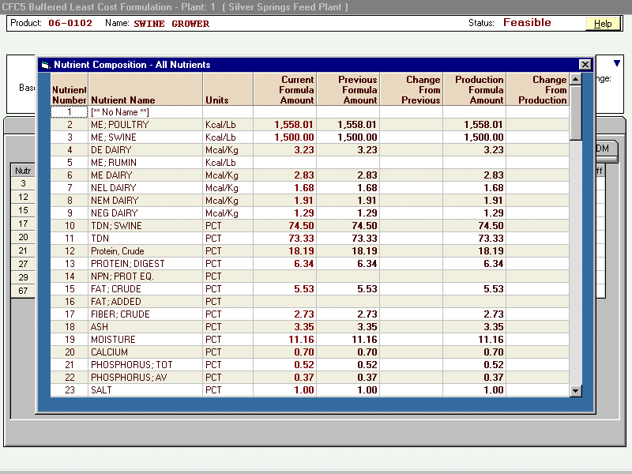

Nutrient tab (cont.)

To add/edit the nutrient values, click the Edit button:
- Change any existing nutrient restriction by clicking on the nutrient and typing the desired minimum or maximum. No entries indicate no restrictions.
- Add nutrients by clicking the Add Nutrient button and then selecting the desired nutrients from the popup. Nutrients can also be added by class by clicking the Add Class of Nutrients button and choosing from the popup menu.
- Remove nutrients by selecting the nutrient then clicking the Remove Nutrient button.
- When editing is complete click the End Edit button.
- Click the Save to make the changes permanent.

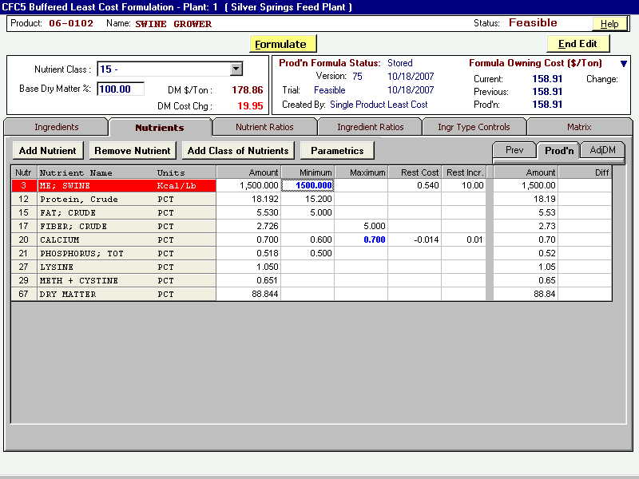

Nutrient tab (cont.)

The only differences in the header portion of the Nutrients tab compared to the Ingredients tab are the two sections on the left:
- The Nutrient Class can be specified here and/or on the Product Maintenance screen. The Nutrient Class is a user-defined grouping of nutrient rows (see the Help file: Contents tab>Nutrients (Ingredients)>Class Assignments).
- The Base Dry Matter textbox allows you to specify a dry matter amount to use in the computation of the nutrient analysis (the example is set at 100%). Select the AdjDM tab on the Nutrients tab. The computed values are shown in the Amount column of the AdjDM tab. The Diff column is the computed value subtracted from the as-mixed value of the nutrient as shown in the Amount column (to the left of the Minimum column). The formula cost of the dry matter formula is shown together with the cost difference to the current formula. To remove the dry matter percent, delete the number in the DM textbox, press Edit, then End Edit.

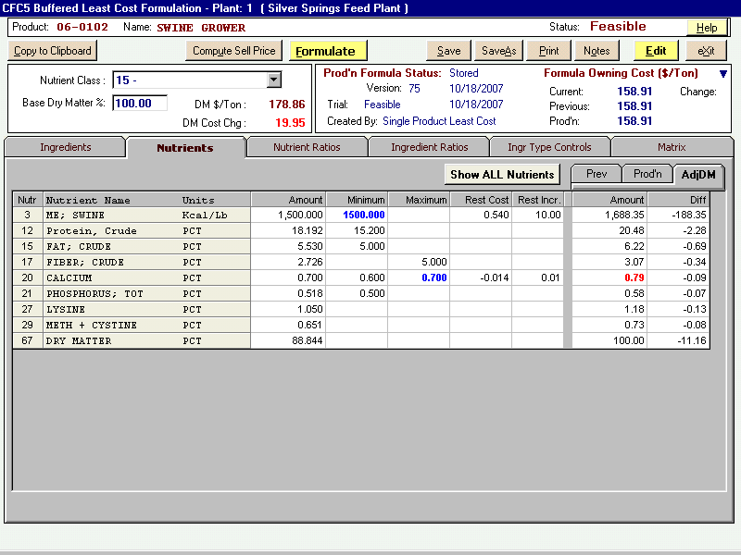

In the above example, note that Calcium is showing in red on the AdjDM tab. The reason is that the dry matter adjustment from 88.844% to 100% increases the solution amount (0.7%) beyond the Maximum restriction (0.7%) to 0.79%.
Nutrient Ratios tab

The Nutrient Ratios tab allows you to establish relationships between nutrient rows. While these relationships can be simple ratios, the system allows a greater level of flexibility because neither units of measure nor absolute inclusion rates are defined. (For example, a ratio between two nutrients of 1 to 1000 or 10 to 10,000 will produce the same result.)

Note that the header is the same as shown on the Ingredient tab.

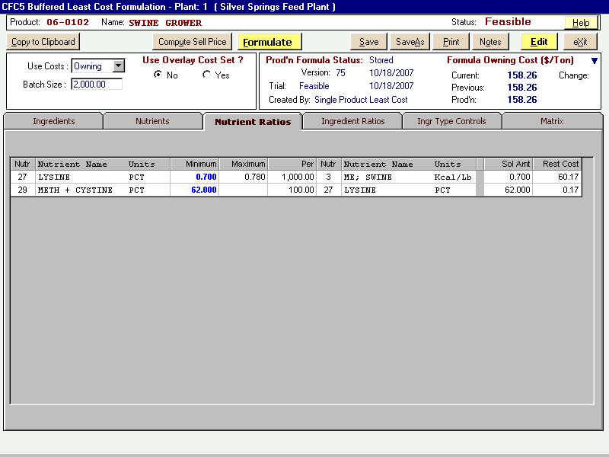

In the above example, nutrient 27, Lysine, is expressed as a ratio of 0.7 minimum and 0.78 maximum per 1000 of nutrient 3, Swine ME. And nutrient 29, Methionine + Cystine, is expressed as a ratio of 62 minimum per 100 nutrient 27, Lysine. In both ratios, the blue numbers in the Minimum column indicates the solution is meeting the minimum restriction.
Nutrient Ratios tab (cont.)

Add ratios by clicking the Edit button and then the Add Ratio button or the Insert Ratio button. (Insert Ratio will respond only if one ratio already exists. It will insert a ratio above the highlighted ratio.) Enter the code number of the first nutrient in the ratio (the numerator) in the Nutr column on the left side of the screen by either:
- typing in the nutrient number; or
- press the F1 key to access the Select Nutrient window and choose the desired nutrient.
Enter the minimum and/or maximum ratio number of this nutrient (numerator) in the
Minimum and Maximum columns. (It is not necessary to enter these values if the results
are only to be viewed and not restricted.)
In the Per column, enter the ratio number (denominator) of the second nutrient in
the ratio. Enter the code number of the second nutrient in the ratio in the next Nutr column.
Edit ratios by clicking on the entry to be edited and typing in the new numbers.
Remove ratios by choosing the ratio and clicking the Remove Ratio button.
When editing is complete click the End Edit button.
Click Save to make the changes permanent.

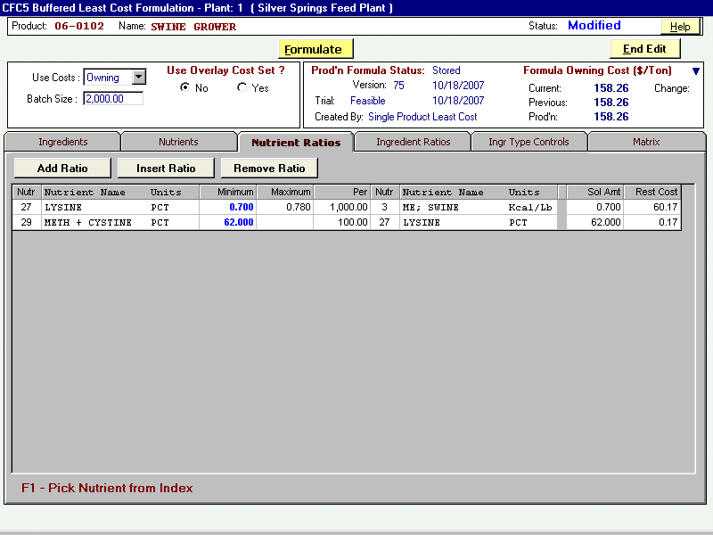

When the Formulate button is clicked, the ratio results will appear in the solution
amount column (Sol Amt). If the ratio is limiting, i.e., it is hitting either the
maximum or minimum limit of the ratio, a blue number will be showing in the
Minimum or Maximum columns, and a restriction cost will appear in the Rest Cost column.
The restriction cost is a per ton cost that applies to a change of one unit (1.0)
of the limiting nutrient (numerator) in the ratio. A red number in the either the
Minimum or Maximum column means that the ratio cannot be met and the formula is infeasible.
Ingredient Ratios tab

The Ingredient Ratios tab allows you to establish relationships between any ingredient
or ingredient type to any other ingredient or ingredient type. (For more information about Ingredient Types, see the Help file: Contents tab>Ingredients>Ingredient Type.) Again, while these relationships can be simple ratios, the system allows a greater level of flexibility because neither units of measure nor absolute inclusion rates are defined. (For example, a ratio between two components of 1 to 1000 or 10 to 10,000 will produce the same result.)

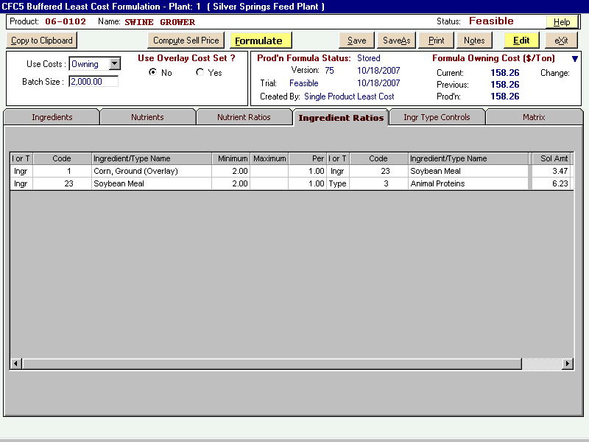

In the above example, two relationships have been specified. Ingredient code 1, Corn, is expressed as a ratio of 2 minimum for every 1 soybean meal. In the second relationship, soybean meal is set as a ratio of 2 minimum for every 1 of Ingredient Type 3, Animal Proteins. The first ratio specifies a relationship between two ingredients. The second ratio specifies a relationship between one ingredient (soybean meal) and all the other ingredients in the formula that are categorized as animal proteins, thus establishing a multi-ingredient relationship. The solution amount in both cases is in excess of the minimum restriction. Again, ratios can be expressed as ingredient to ingredient, ingredient to type, type to ingredient, and type to type.

Ingredient Ratios tab (cont.)

Add ratios by clicking the Add Ratio button or the Insert Ratio button. (Insert Ratio
will respond only if one ratio already exists. It will insert a ratio above the highlighted
ratio.)
Enter the designation of the first component in the ratio (numerator) as an ingredient
or type by either:
- entering an I (for ingredient) or T (for type) in the first column; Or
- pressing the F1 key and choosing ingredient or type from the scroll down menu.
Press the right arrow button or click in the Code column and enter the ingredient
code or the type code, (or press F1 and select from the Select Ingredient or Select
Ingredient Type window that appears).
Enter the minimum and/or maximum ratio number of this ingredient or type
in the Minimum and Maximum columns. These entries represent the numerator of the ratio. In the Per column, enter the ratio number of the second ingredient or type in the ratio. This entry represents the denominator of the ratio. Enter the I or T designation and code number of the second component in the ratio.

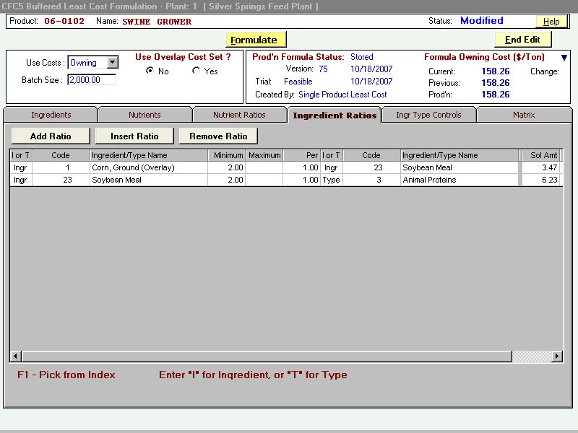

Edit any existing ratio by clicking in any entry and typing in the new numbers.

Remove ratios by choosing the ratio and pressing the Remove Ratio button.

When editing is complete click the End Edit button. Click Save to make the changes permanent; make the desired selections from the prompt.

When the Formulate button is clicked the ratio results will appear in the solution
amount column (Sol Amt). If the ratio is limiting, i.e., it is hitting either the
maximum or minimum limit of the ratio, it will be indicated by a blue number in the
Minimum or Maximum columns. A red number indicates that the bound cannot be met and the result is infeasible.
Ingredient Type Controls tab

The Ingredient Type Controls tab allows the application of ingredient groupings to formula restrictions. Setting minimum and/or maximum restrictions to ingredient types instructs the solution algorithm to select the most economical ingredient or ingredients within the type for the finished formula. For example, you may have three grains offered to your formula, each with a maximum restriction of 10%. But you want a maximum of 20% total grains. By categorizing the three grains into the Grains type, you can enter a maximum of 20% Grains (as type) on this tab and the solution will return the most economical formula, whether it be no grains, one grain, or a combination of two or all three. And the solution will neither exceed the 20% maximum total grains nor the 10% maximum of each individual grain.

The tab shows all the current ingredient types that the user has defined (to create Types and assign your ingredients to those types, see the Help file: Table of Contents>Ingredients>Ingredient Type).

Click the Edit button to initiate the editing process. Type in the minimum and/or
maximum (Min Pct and Max Pct columns) for each type to be controlled. Click End Edit when editing is complete.
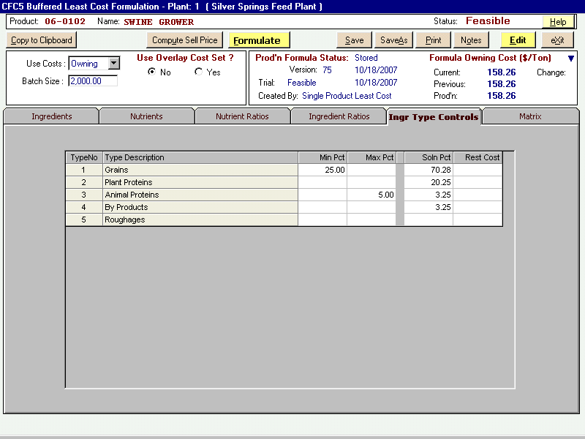

The above example shows that the user created five Types, and a minimum of 25% Grains and 5% maximum of Animal Proteins is specified for this formula.

When the Formulate button is clicked the results will appear in the solution percent
column (Sol Pct). If the restriction is limiting, i.e., it is hitting either the
maximum or minimum limit, it will be indicated by a blue number in the Min Pct or
Max Pct columns and a number will appear in the restriction cost (Rest Cost) column.
Restriction cost is a per ton cost that applies to a change of one unit of the limiting
restriction. A red number indicates that the restriction cannot be met and the result is infeasible.

Matrix tab

The Matrix tab allows the user to view the ingredient nutrient values for each ingredient in the formula. Only the nutrient rows specified in the formula will be listed.
The left side of the screen lists the ingredients and their percentages in the formula
(Formula % column). Use the down arrow to scroll through the ingredients.
On the right side of the screen, the nutrient profile of the highlighted ingredient
is displayed in the ingredient amount (Ingr Amt) column. The formula amount column
(Form Amt) is the product of the numbers in the Formula % column and the ingredient
amount column (Ingr Amt). The number in the % Total column is the contribution of
the number in the Formula Amount column to the total amount of that nutrient in the
formula.

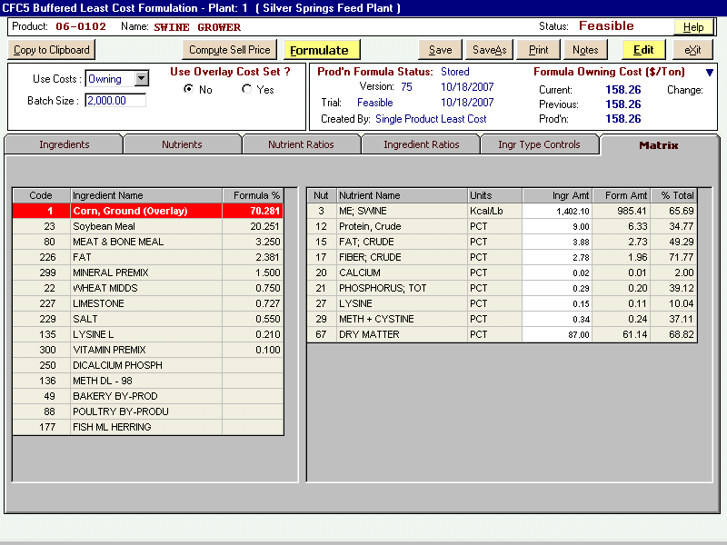

The individual ingredient nutrient rows (the numbers in the Ingr Amt column) may be temporarily changed to evaluate the effect on the formula. Clicking the Edit button allows you to change any nutrient value in the Ingr Amt column for any ingredient listed. These changes are temporarily stored when the End Edit button is selected. When ingredient editing is complete, click End Edit, then the Formulate button to evaluate the effect of the changes on the solution. All nutrient changes will revert back to the original numbers upon exiting the screen. Any formula solution obtained using any altered ingredient has the potential to be saved and stored to production. Caution is advised

